**Assignment 1:**

Analyze a given business scenario and create an ER diagram that includes entities, relationships, attributes, and cardinality. Ensure that the diagram reflects proper normalization up to the third normal form.

**ER Diagram:**

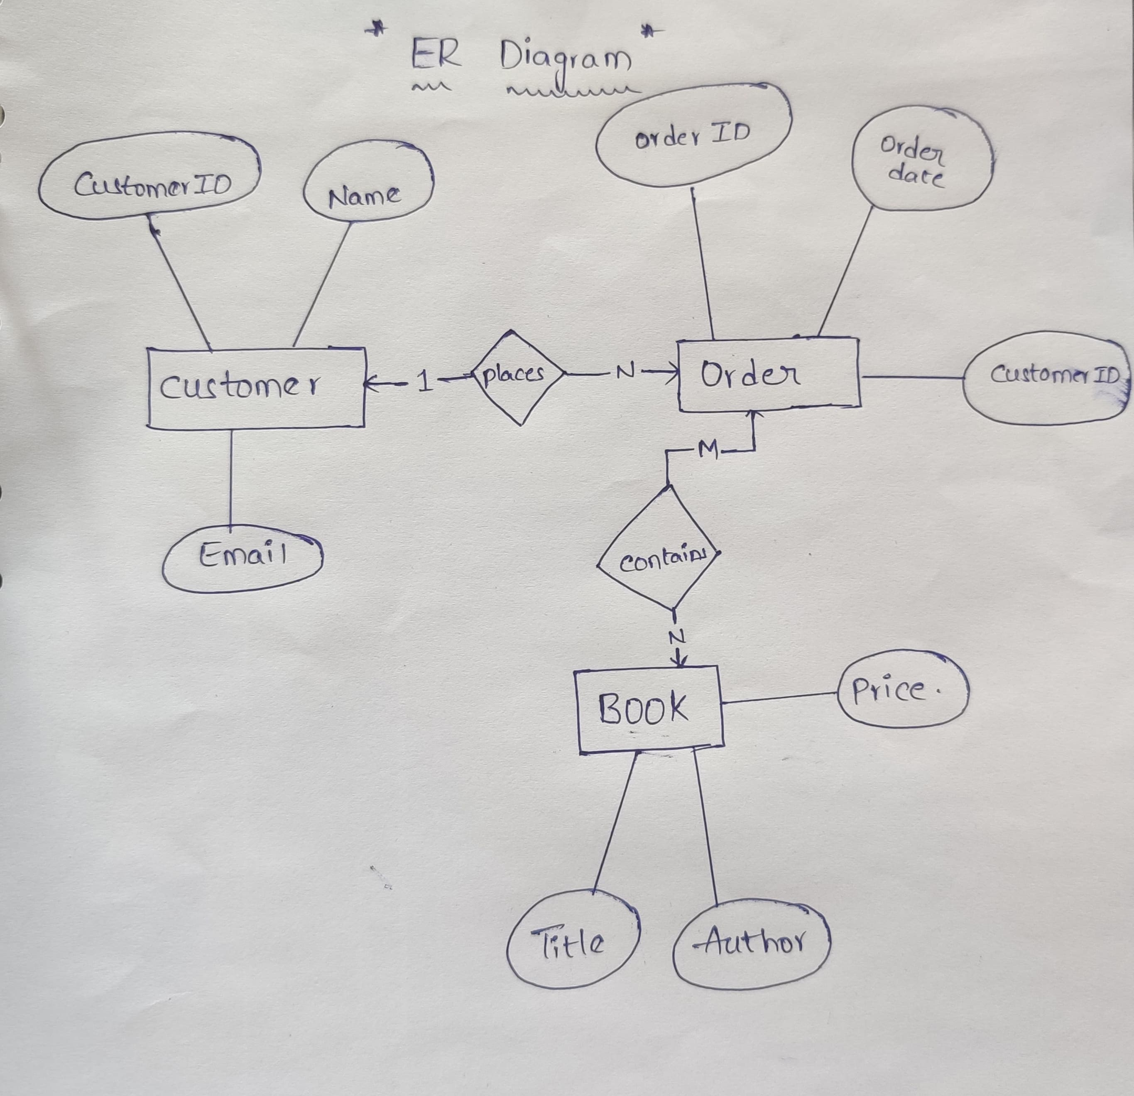

**Explanation:**

* The Customer entity has attributes CustomerID, Name, and Email.
* The Order entity has attributes OrderID, OrderDate, and CustomerID (which is a foreign key referencing Customer).
* The Book entity has attributes Title, Author, and Price.
* The Customer places an Order (1:N relationship).
* The Order contains Book (M:N relationship, which would typically involve an associative entity like OrderDetails).

**Assignment 3:**

Explain the ACID properties of a transaction in your own words. Write SQL statements to simulate a transaction that includes locking and demonstrate different isolation levels to show concurrency control.

**Answer:**

* **Atomicity**: This property ensures that all the operations within a transaction are treated as a single unit. Either all of them are executed successfully, or none are. It’s like saying, “Do everything or do nothing.”
* **Consistency**: Consistency ensures that a transaction can only bring the database from one valid state to another, maintaining the database’s predefined rules, such as unique keys, foreign keys, and constraints.
* **Isolation**: Isolation determines how transaction integrity is visible to other users and systems. A transaction should appear as though it is the only operation being executed in the system.
* **Durability**: Once a transaction has been committed, it will remain so, even in the event of a system failure. This means the changes made by the transaction are permanent and must be stored in non-volatile memory.

**SQL Statements:**

-- Start a transaction with explicit locking

BEGIN TRANSACTION;

-- Assume we have a table `accounts` with columns `id`, `user_name`, and `balance`

-- Let's lock the account with id 1 for update

SELECT * FROM accounts WHERE id = 1 FOR UPDATE;

-- Perform some operations, like transferring money from one account to another

UPDATE accounts SET balance = balance - 100 WHERE id = 1;

UPDATE accounts SET balance = balance + 100 WHERE id = 2;

-- End the transaction

COMMIT;

-- To demonstrate different isolation levels, we can set the isolation level at the beginning of the transaction

SET TRANSACTION ISOLATION LEVEL READ UNCOMMITTED;

-- Other levels include READ COMMITTED, REPEATABLE READ, and SERIALIZABLE

**Assignment 2:**

Design a database schema for a library system, including tables, fields, and constraints like NOT NULL, UNIQUE, and CHECK. Include primary and foreign keys to establish relationships between tables.

**Program:**

create database library_system;

use library_system;

-- Table for storing book details

CREATE TABLE Books (

BookID INT PRIMARY KEY,

Title VARCHAR(255) NOT NULL,

Author VARCHAR(255) NOT NULL,

ISBN VARCHAR(13) UNIQUE NOT NULL,

PublicationYear YEAR,

Genre VARCHAR(100),

CHECK (PublicationYear > 1800)

);

-- Table for storing member details

CREATE TABLE Members (

MemberID INT PRIMARY KEY,

FirstName VARCHAR(255) NOT NULL,

LastName VARCHAR(255) NOT NULL,

Email VARCHAR(255) UNIQUE NOT NULL,

JoinDate DATE NOT NULL,

);

-- Table for storing book loans

CREATE TABLE BookLoans (

LoanID INT PRIMARY KEY,

BookID INT,

MemberID INT,

IssueDate DATE NOT NULL,

DueDate DATE NOT NULL,

ReturnDate DATE,

FOREIGN KEY (BookID) REFERENCES Books(BookID),

FOREIGN KEY (MemberID) REFERENCES Members(MemberID),

CHECK (IssueDate <= DueDate)

);

**Assignment 4:**

Write SQL statements to CREATE a new database and tables that reflect the library schema you designed earlier. Use ALTER statements to modify the table structures and DROP statements to remove a redundant table.

**Program:**

create database library_system;

use library_system;

CREATE TABLE Books (

BookID INT PRIMARY KEY,

Title VARCHAR(255) NOT NULL,

Author VARCHAR(255) NOT NULL,

ISBN VARCHAR(13) UNIQUE NOT NULL,

PublicationYear YEAR,

Genre VARCHAR(100),

CHECK (PublicationYear > 1800)

);

CREATE TABLE Members (

MemberID INT PRIMARY KEY,

FirstName VARCHAR(255) NOT NULL,

LastName VARCHAR(255) NOT NULL,

Email VARCHAR(255) UNIQUE NOT NULL,

JoinDate DATE NOT NULL,

);

CREATE TABLE BookLoans (

LoanID INT PRIMARY KEY,

BookID INT,

MemberID INT,

IssueDate DATE NOT NULL,

DueDate DATE NOT NULL,

ReturnDate DATE,

FOREIGN KEY (BookID) REFERENCES Books(BookID),

FOREIGN KEY (MemberID) REFERENCES Members(MemberID),

CHECK (IssueDate <= DueDate)

);

-- Alter the 'Books' table to add a new column for 'Publisher'

ALTER TABLE Books

ADD Publisher VARCHAR(255);

-- Drop the 'Genre' column from the 'Books' table as it is redundant

ALTER TABLE Books

DROP COLUMN Genre;

-- Remove the 'BookLoans' table if it's no longer needed

DROP TABLE BookLoans;

**Assignment 5:**

Demonstrate the creation of an index on a table and discuss how it improves query performance. Use a DROP INDEX statement to remove the index and analyze the impact on query execution.

**Explanation:**

Let’s take the Books table from the library database schema as an example. We’ll create an index on the Author column, which is a common field for search queries.

**-- Create an index on the 'Author' column of the 'Books' table**

**CREATE INDEX idx_author ON Books(Author);**

Creating an index on the Author column allows the database to quickly locate the rows associated with a particular author without scanning the entire table. This is similar to an index in a book, which helps you find information quickly without reading every page. When a query searches for books by a specific author, the database uses the index to efficiently locate all books by that author.

Now, let’s discuss the impact of removing this index:

**-- Drop the index 'idx_author' from the 'Books' table**

**DROP INDEX idx_author ON Books;**

Dropping the index means that the database will no longer have a quick reference for the Author column. Consequently, query performance can degrade, especially for large tables, because the database must perform a full table scan to find rows matching the query criteria, which is much slower than using an index.

In summary, an index can significantly improve query performance by providing a fast path to the data rows in a table based on the indexed columns. However, indexes also have drawbacks:

They consume additional storage space.

They can slow down write operations like INSERT, UPDATE, and DELETE, as the index must be updated in addition to the table data.